Word Problem Practice Answers
Problem #1
Sally bought 2 whole pizzas for her sleepover with her 4 best friends. Each of her friends requested a specific amount of pizza. Kelly wanted 1/4 of a whole pizza. Jenny wanted 1/3 of a whole pizza. Laura wanted 1/2 of a whole pizza. Melissa wanted 1/4 of a whole pizza. How much of the pizza was left for Sally?
Draw a Picture!
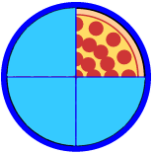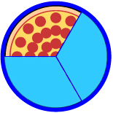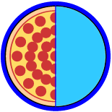
Answer: There is 2/3 of a whole pizza left for Sally to eat.
Problem #2
I am a 4-sided polygon. There are not many objects that are my shape. Two of my sides are equal lengths. Two of my sides are not parallel. Two of my sides are parallel. What am I?
Underline important facts.
Draw a diagram.

Answer: Trapezoid

Problem #3
You have been wanting to buy a new video game to play, but you do not have enough money to purchase it yet. Your dad agrees to pay you for mowing the front lawn to help you earn enough money for the video game. Your dad will pay you $0.02 a square foot. The front lawn is 64 feet long and 32 feet wide. What is the square footage of the front yard and how much money will you earn if you mow it completely?
Use the C.U.B.E Method
Circle the numbers.
Underline important words.
64 X 32 = 2,048
2,048 X $0.02 = $40.96
Box the question.
Eliminate unnecessary information.

Use multiplication to solve.

Answers: 2,048 square feet; $40.96

